|  |
| --- |
| Predictive Health Notification  Alinity I Vacuum Leak |
| ALINITY ci Immunoassay Analyzer  Anthony Schuler  July 9, 2018 |

**PHN - Alinity i Vacuum Leak Spec Sheet for Apollo**

**References**

APLM ID

**Summary**

To implement a Predictive Health Notification (PHN) for Alinity-i Analyzers that will detect leaks in the vacuum assembly.

|  |  |
| --- | --- |
| PHN Descriptor | Alinity IA Vacuum Leak |
| PHN Experience Code / Name | CCE1 - PHN_Alinity_IA; PHN_Vacuum_IA; Leak |
| PHN KM Article Number/ Name | K70550866 / PHN Alinity IA: Vacuum System Leak |
| Service Level | 2- Advanced Service |
| Always On Package | Always On 01DP5- 01, 02, 03, 09, 70, 80, 83, 84, 89 |
| IDA Table | IDAQOWNER.ICQ_VACUUMPRESSUREDATA |
| IDA Table Fields | MODULESN  LOGDATE_LOCAL  ADCVALUE  ADCVALUELEAKTEST |
| Analysis Frequency | Daily |
| Data Required | Previous 7 days |
| Data Aggregation | Mean |
| Run Time Estimate | N/A |
| Flag Criteria | For each MODULESN:  If (Mean Percent Leak Difference > 7) for 2 days within a 7 calendar day window then **Flag**,  else **No Flag**. |
| Probable Failure Modes | Faulty vacuum assemblies which could be caused by hardware failures or loose connections and fittings in the vacuum tubing. |
| Suppression Experience Codes | AA3Z |
| Applicable Work Done Codes (WDC) | D3V*: Transport, Robotics, Waste Disposal & Other Hardware: Waste Accumulator:Vacuum System Issue/Failure  A1V*: Transport, Robotics, Waste Disposal & Other Hardware: Waste Accumulator:Vacuum System Issue/Failure |

**Data Processing Steps**

|  |  |
| --- | --- |
| Data Processing Steps | |
| 1 | Query all data from the previous 7 day for each instrument (IDA Table: IDAQOWNER.ICQ_VACUUMPRESSUREDATA). |
| 2 | Calculate Percent Leak Difference = [(ADCVALUELEAKTEST – ADCVALUE)/ADCVALUE]*100. |
| 3 | Calculate Daily Mean of Percent Leak Difference by instrument and day. |
| 4 | Flag any instrument where the Daily Mean Percent Leak Difference is > 7 for 2 days within a 7 calendar day window. |

**APPENDIX 1:** CCE1 - PHN_Alinity_IA; PHN_Vacuum_IA; Leak

**Algorithm Code**

SELECT

evalflags.MODULESN,

evalflags.SevenDAYGROUP

FROM

(SELECT

flags.MODULESN,

SUM(CASE WHEN trunc(flags.LogDate) >= TRUNC(SYSDATE) - 7 AND TRUNC(flags.LogDate) < TRUNC(SYSDATE)

THEN 1

ELSE 0

END) AS SevenDAYGROUP

FROM

(SELECT

evals.MODULESN,

evals.LogDate,

evals.meanPercentDiff

FROM

(SELECT

raws.MODULESN,

(trunc(raws.LOGDATE_LOCAL)) AS LogDate,

AVG(raws.PercentDiff) AS meanPercentDiff

FROM

(SELECT

t1.MODULESN,

t1.LOGDATE_LOCAL,

t1.VACUUMSTATENAME,

t1.VERIFYVACUUMSUBSTATENAME,

100*(t1.ADCVALUELEAKTEST-t1.ADCVALUE)/t1.ADCVALUE AS PercentDiff,

t1.ADCVALUE,

t1.ADCVALUELEAKTEST

FROM IDAQOWNER.ICQ_VACUUMPRESSUREDATA t1

WHERE t1.LOGDATE_LOCAL >= SYSDATE-7 AND t1.VACUUMSTATENAME = 'ConcludeLeakTest') raws

GROUP BY

raws.MODULESN,

trunc(raws.LOGDATE_LOCAL)

ORDER BY

raws.MODULESN,

trunc(raws.LOGDATE_LOCAL) )evals

WHERE

meanPercentDiff>=7 ) flags

GROUP BY

flags.MODULESN

ORDER BY

flags.MODULESN)evalFlags

WHERE

evalFlags.SevenDAYGROUP>=2

**Apollo Algorithm Details**

(* is Mandatory)

|  |  |
| --- | --- |
| **Apollo Details** |  |
| Algorithm ID * | Alinity IA Vacuum Leak |
| Algorithm Name * | Alinity IA Vacuum Leak |
| Algorithm Description * | To detect leaks in the vacuum assembly. |
| Product Family * | Alinity IA |
| Algorithm Group * | Alinity Waste |
| Functional Area | N/A |
| Algorithm Category 1 | N/A |
| Algorithm Category 2 | N/A |
| Algorithm Category 3 | N/A |
| Remaining Useful Life Value | 7 |
| Remaining Useful Life Unit | Day |
| Keep Results Num Days | 14 |
| **Routine Details** |  |
| Routine Source | Define New Routine |
| Routine Type | Oracle Procedure |
| Run Mode | Batch |
| Routine Invoke Command | PHM_ICQ_Vacuum_Leak_PROC |
| Status | Enable |
| **ODS Routine Details** |  |
| ODS Routine Name | PHM_ODS_ICQ_VACUUMPMDATA_PROC |
| **Predictive Health Notification Details** |  |
| PHN Code | PHN_Alinity IA_CCE1 |
| Issue Description (Use Algorithm Name) |  |
| Experience Code | CCE1 |
| **Knowledge Management DB Articles** |  |
| KM Article ID | K70550866 |
| KM Article | PHN Alinity IA: Vacuum System Leak |
| **Parameters** |  |
| Parameter Group Name | ICQ_VACUUMLEAK |
| **Parameter Name** | **Parameter Values** |
| IHN_LEVEL3_DESC | AIinity IA Vacuum Leak |
| VACUUMLEAK_MEANDIFF | 7 |
| VACUUMLEAK_FLAGDAYS | 2 |
| VACUUMLEAK_NDAYS | 7 |
| THRESHOLDS_COUNT | 1 |
| THRESHOLD_DESCRIPTION | AIinity IA Vacuum Leak |
| **Chart Details** |  |
| Chart Title | Alinity IA Vacuum Leak |
| Chart Type | Line Chart |
| Chart Threshold Parameter | ICQ_VACUUMLEAK-THRESHOLDS_COUNT |
| Group ID | Group 7 |
| Chart X Axis Name | Date |
| Chart Y Axis Name | Threshold Count |

**APPENDIX 2:** Algorithm Transition to Apollo – PHM Specialist to Apollo Developer

**Data Set Description**

The data set for this transition was retrieved from the IDAQOWNER.ICQ_VACUUMPRESSUREDATA table within the DABBTO database. Data was collected for all available instruments between June, 25 2018 and June 26, 2018.

**PHM Specialist Analysis Output**

The following 4 instrument-days (MODULESN-DAY) were identified as violating the algorithm by the PHM Specialist:

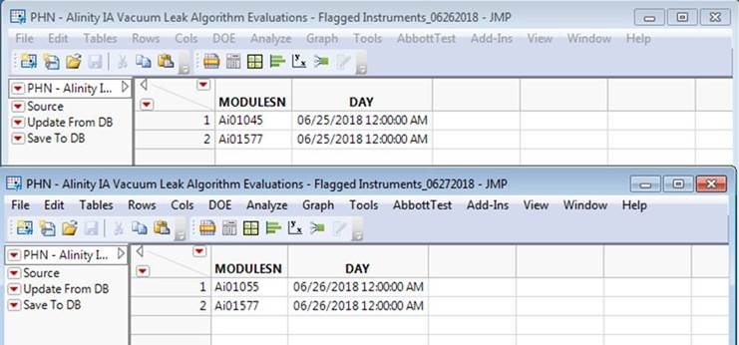

**Apollo Developer Analysis Output**

The following instrument-day (SN-FLAG_DATE) was identified as violating the algorithm by the Apollo Developer (note that where the Apollo Developer and PHM Specialist don’t match is because the instruments do not exist in the Apollo environment, and therefore have no data to run the algorithm against):

June 25, 2016:

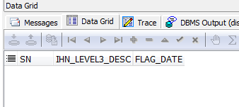

June 26, 2018:

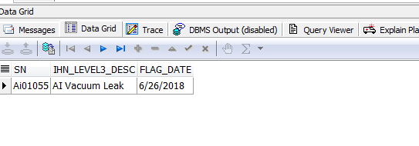

**Algorithm Transition Summary**

Based on the outputs from both the Apollo Developer and PHM Specialist, the Apollo Developer’s understanding of the delivered algorithm is confirmed. Both the Apollo Developer and PHM Specialist analyzed the same data set and got the same results (with the exception of the instruments not in Apollo as mentioned previously). In particular, the MODULESN/SN and DAY/FLAG_DATE fields matched. This means that both the Apollo Developer and PHM Specialist flagged the same algorithm violations within the given data set.